1. Unable to generate the report with all categories 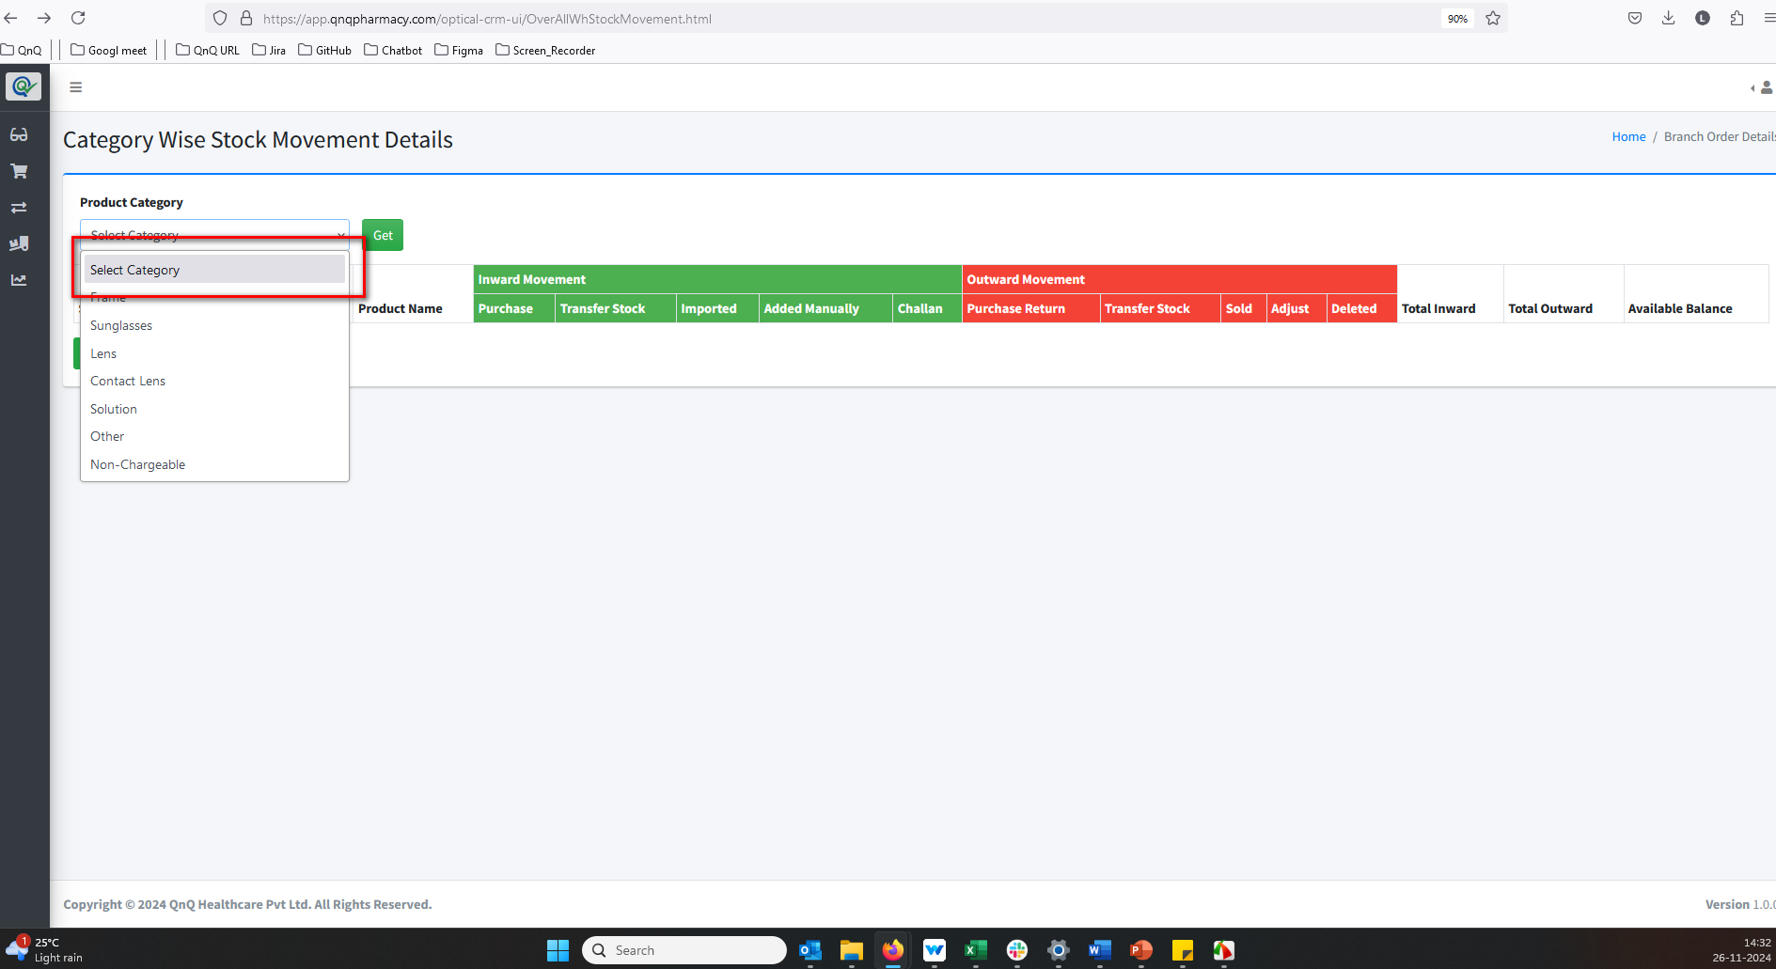 //
2. Even with an empty list grid, the downloaded Excel file shows certain values 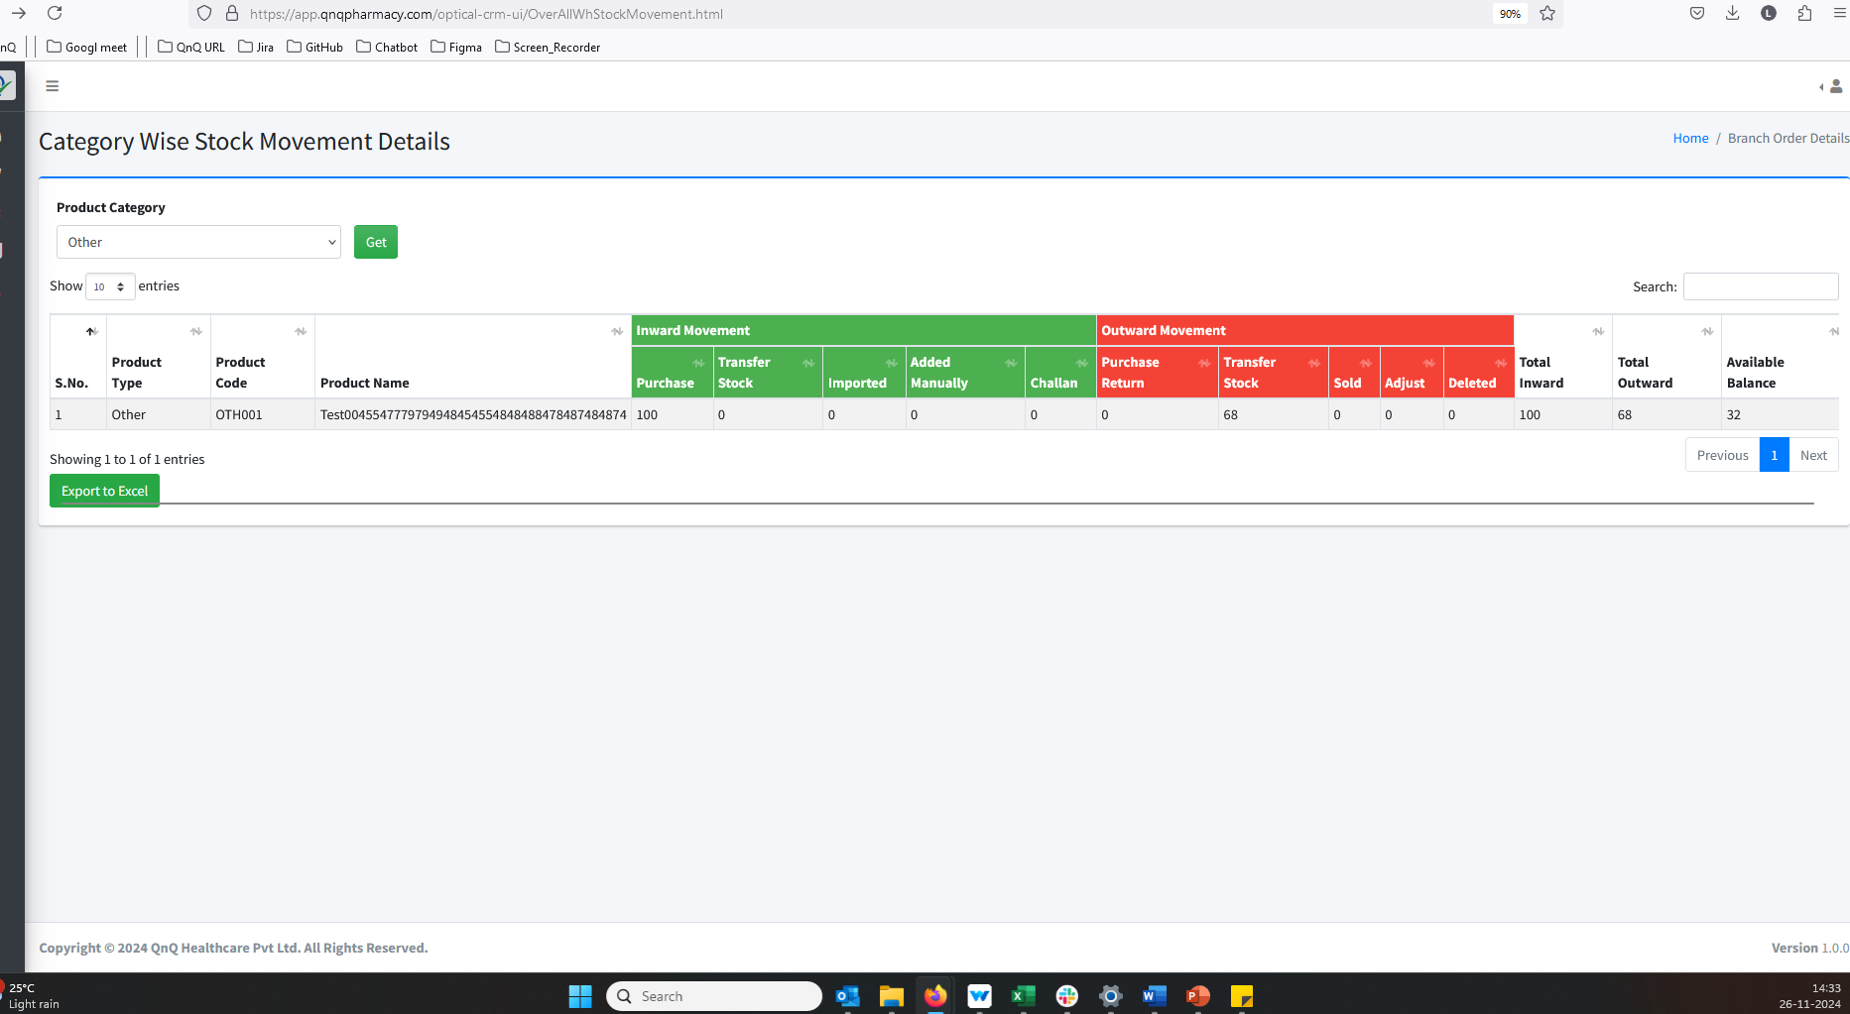 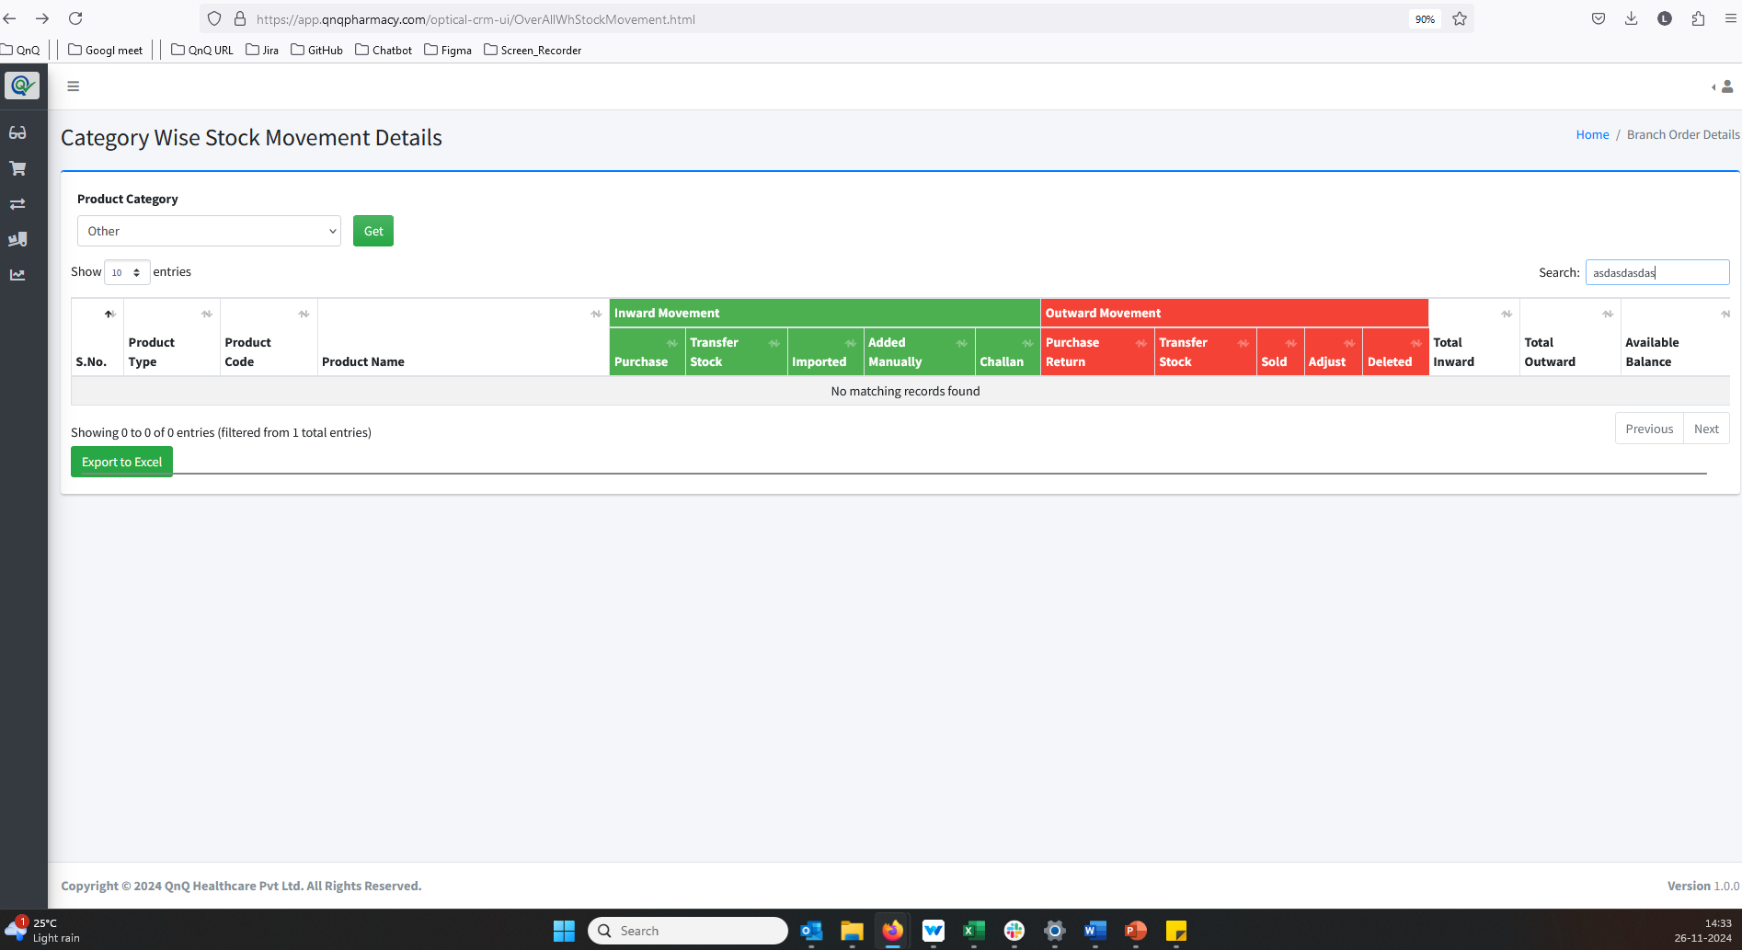 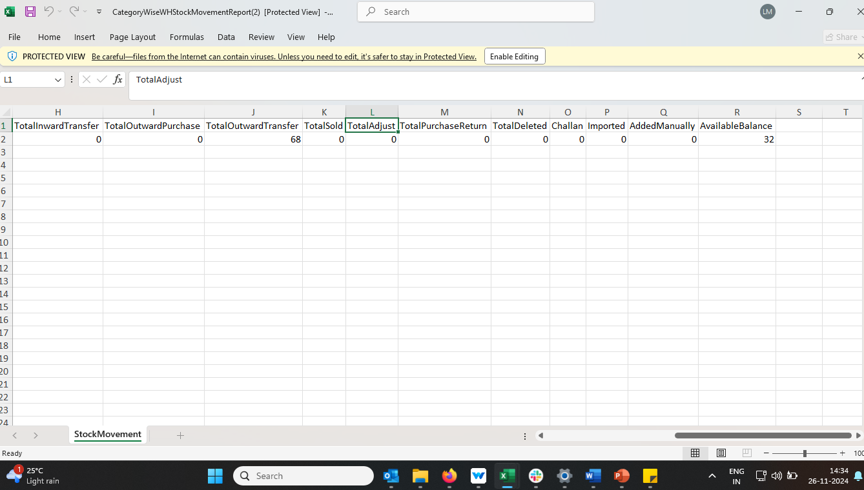 //
3. The system takes a long time to load when the "Get" button is clicked 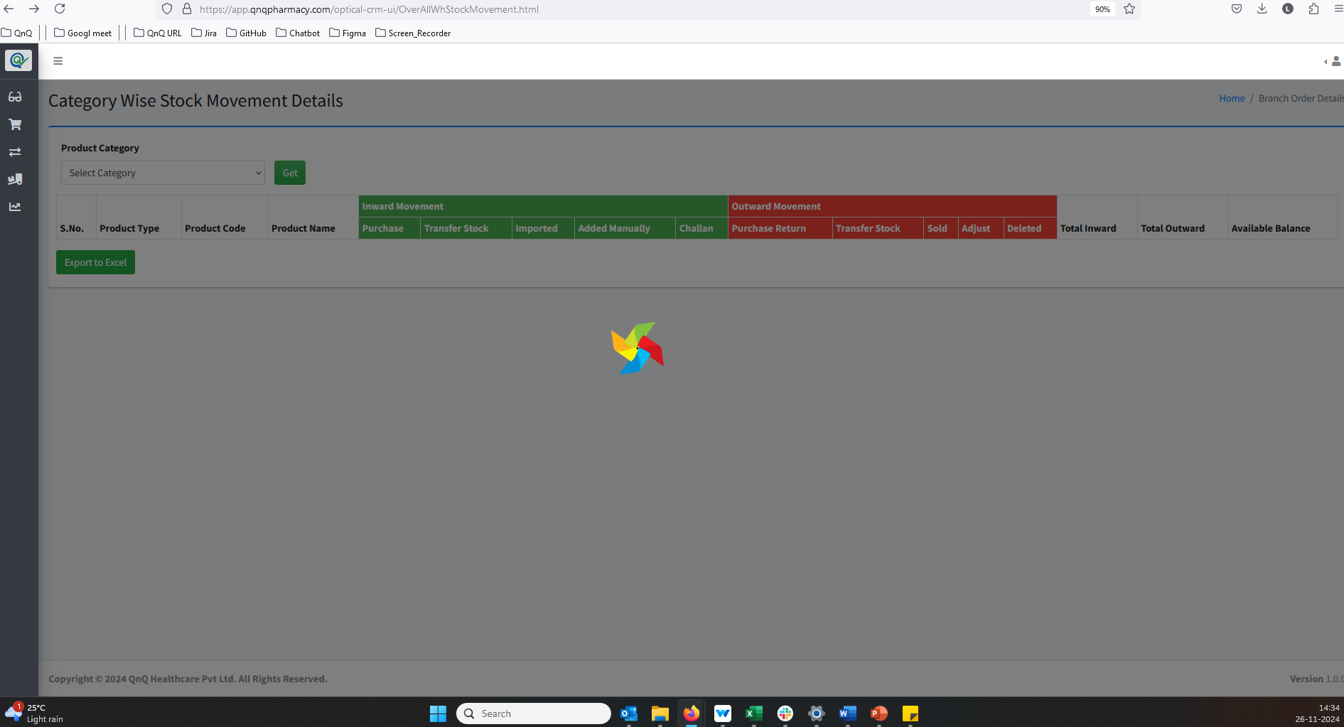 //
4. No record available message not display in list grid 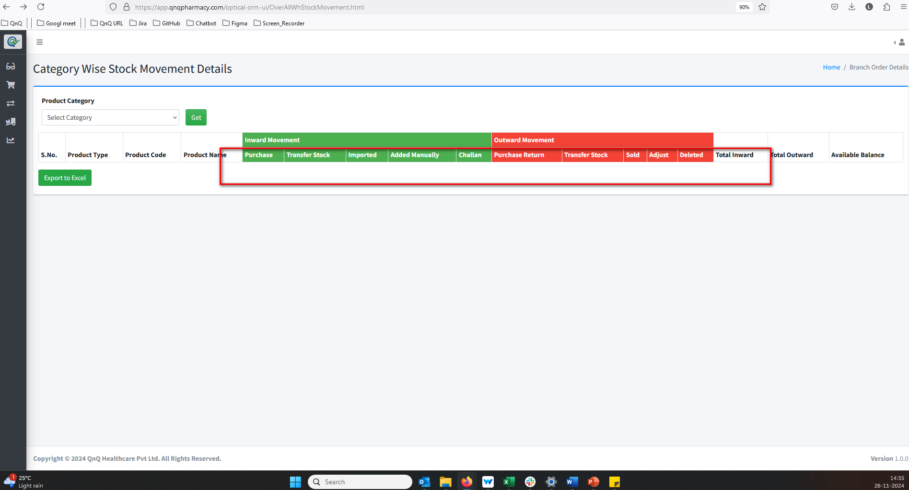 //
5. Refresh icon not available to clear the search filter values 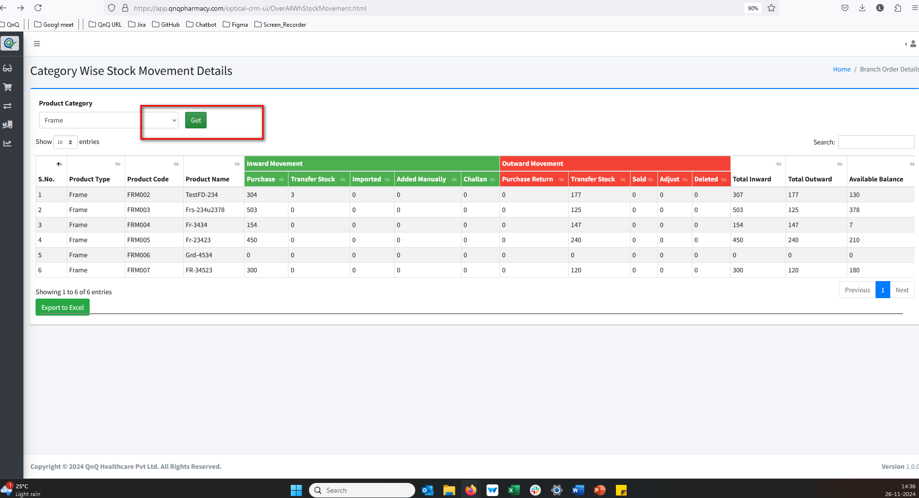 //
6. The download options appear at the bottom of the list grid 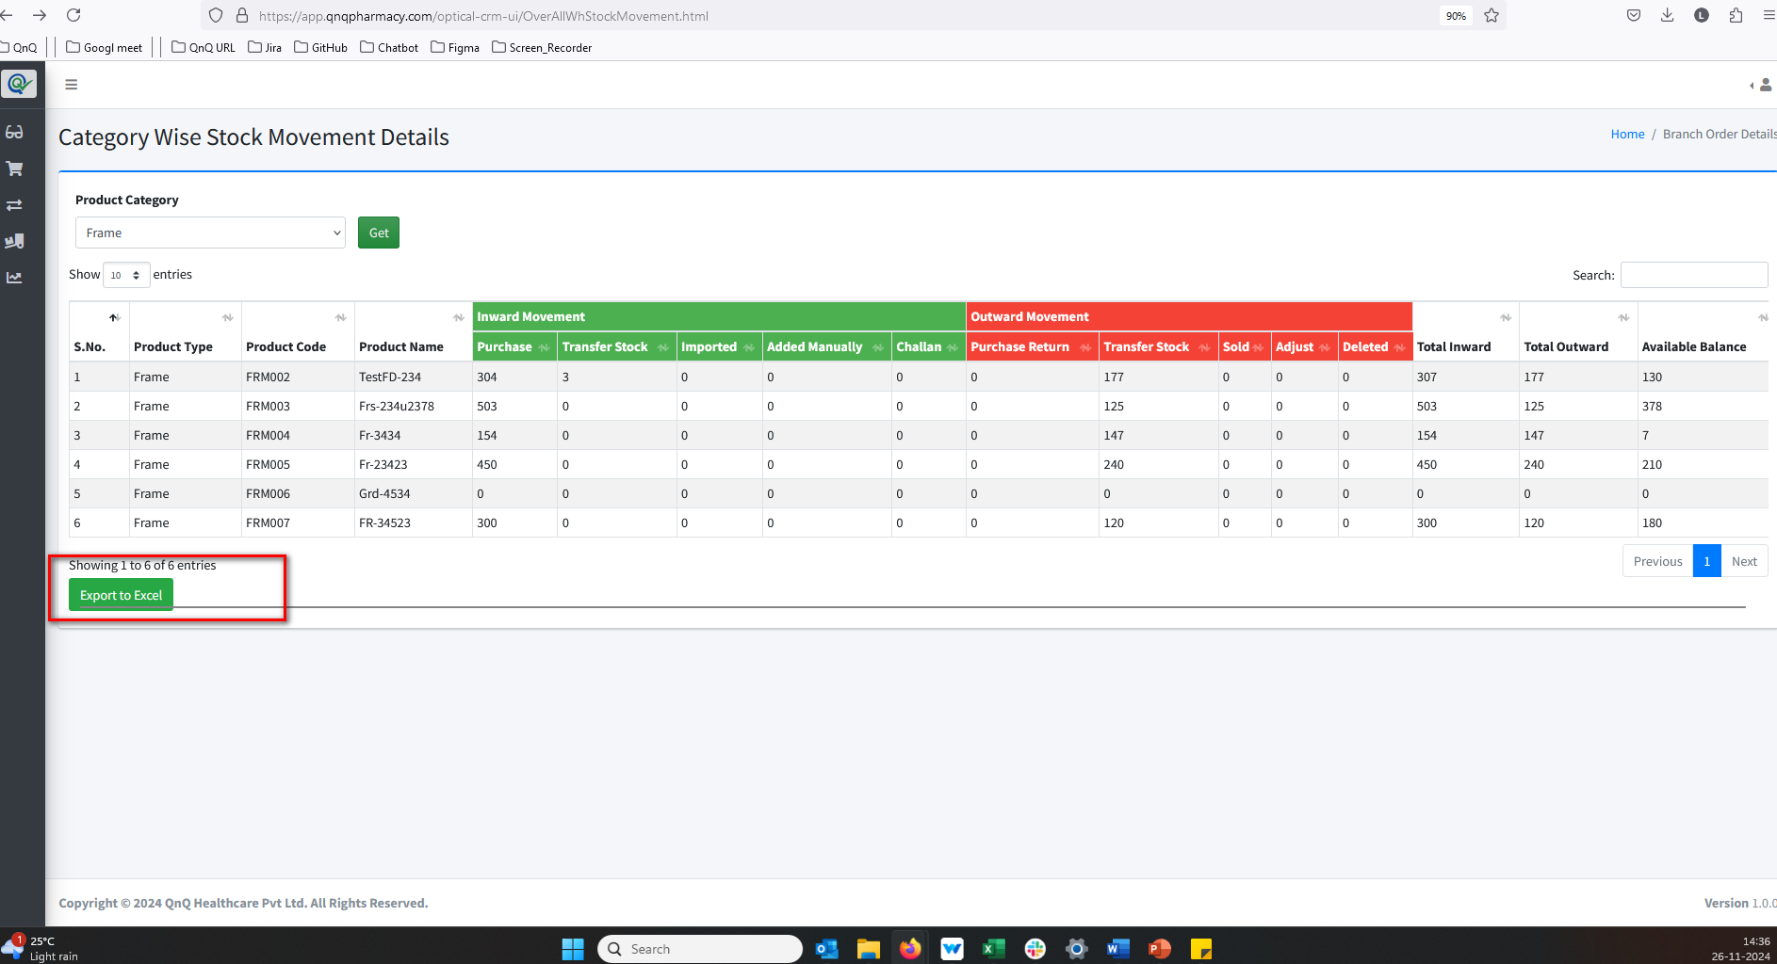 //
7. The list grid displays values after clearing the selected filter 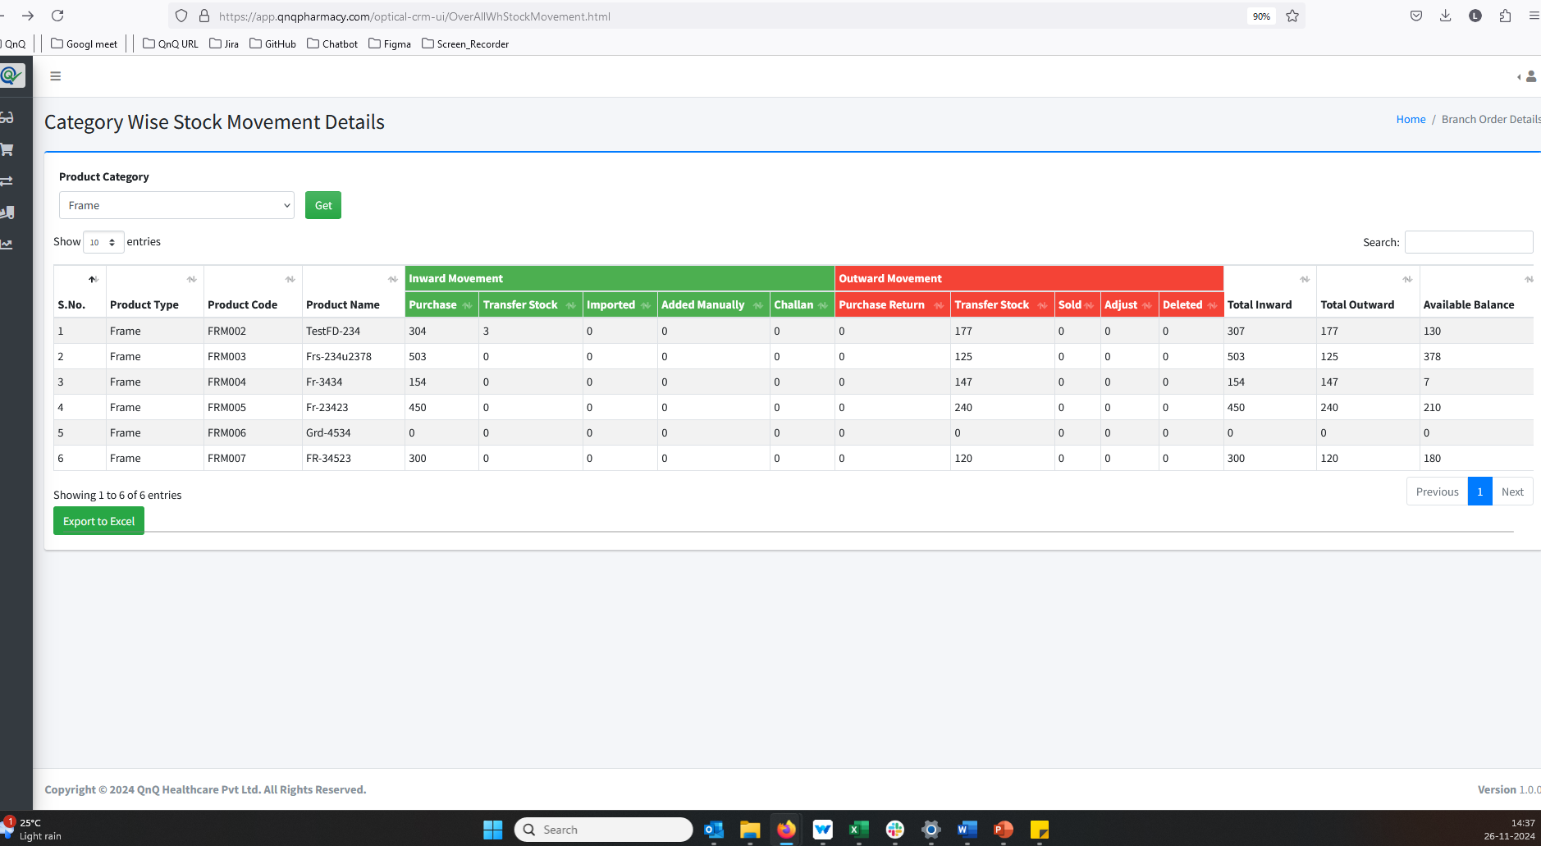 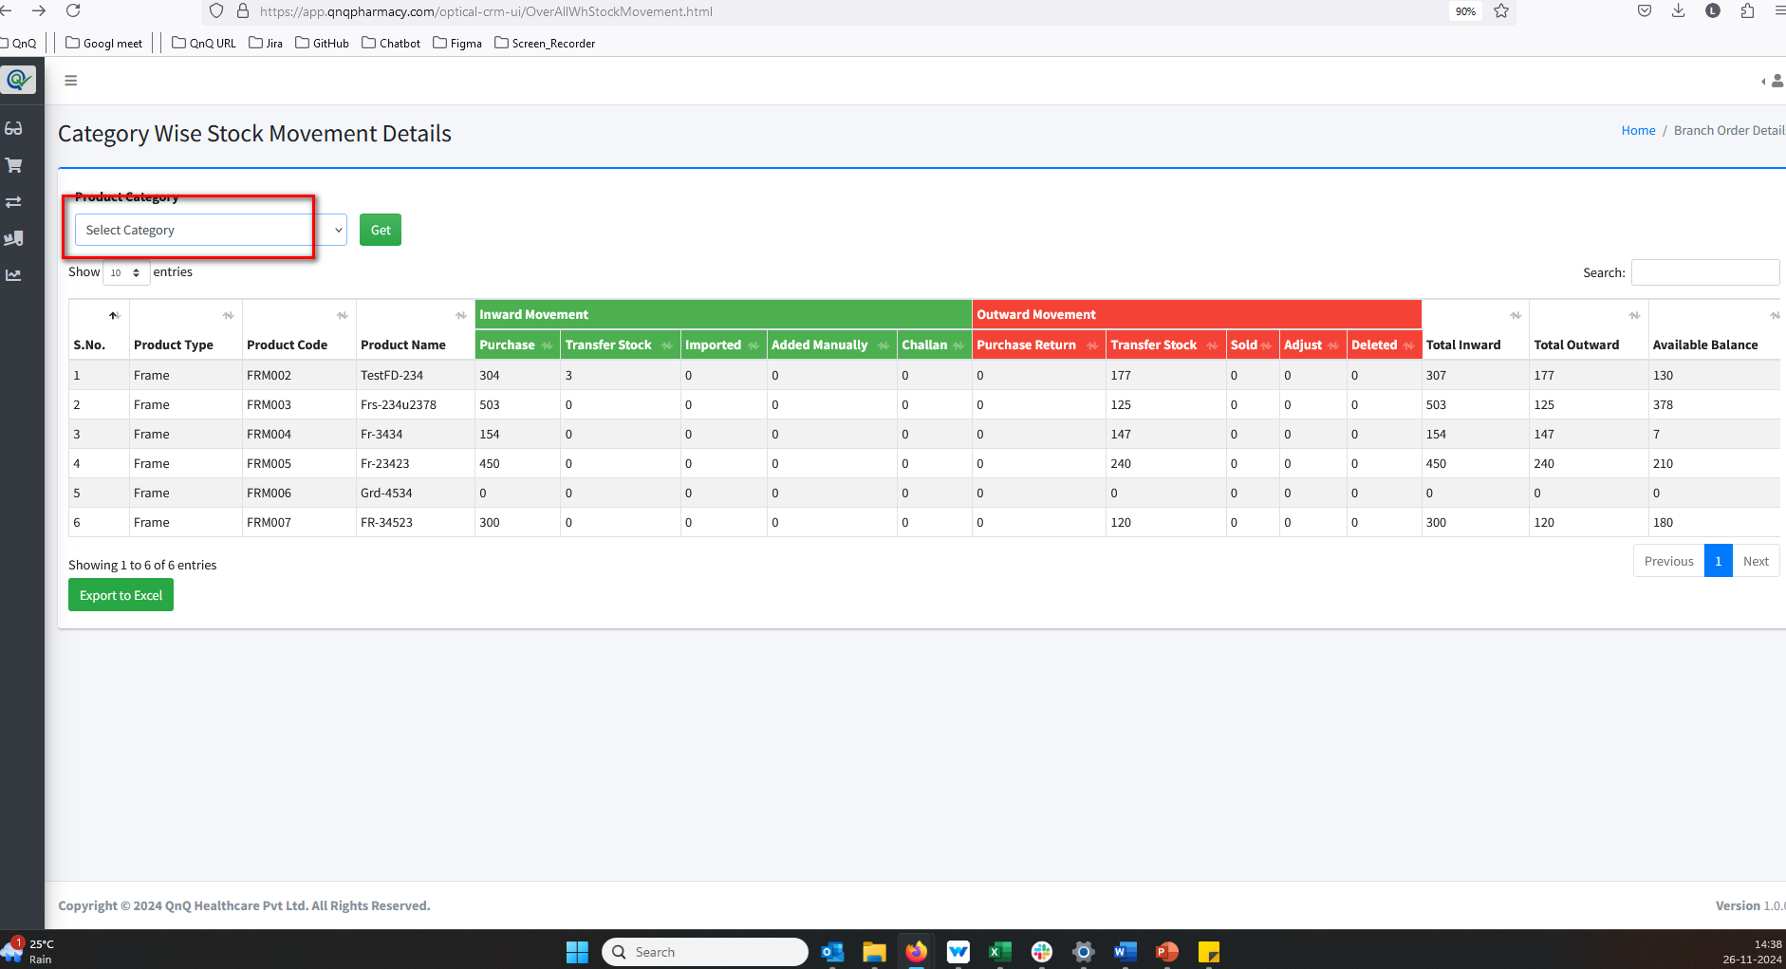 //
8. Search filter and Pagination not display  //
9. An unwanted page is being opened when clicking the Home button 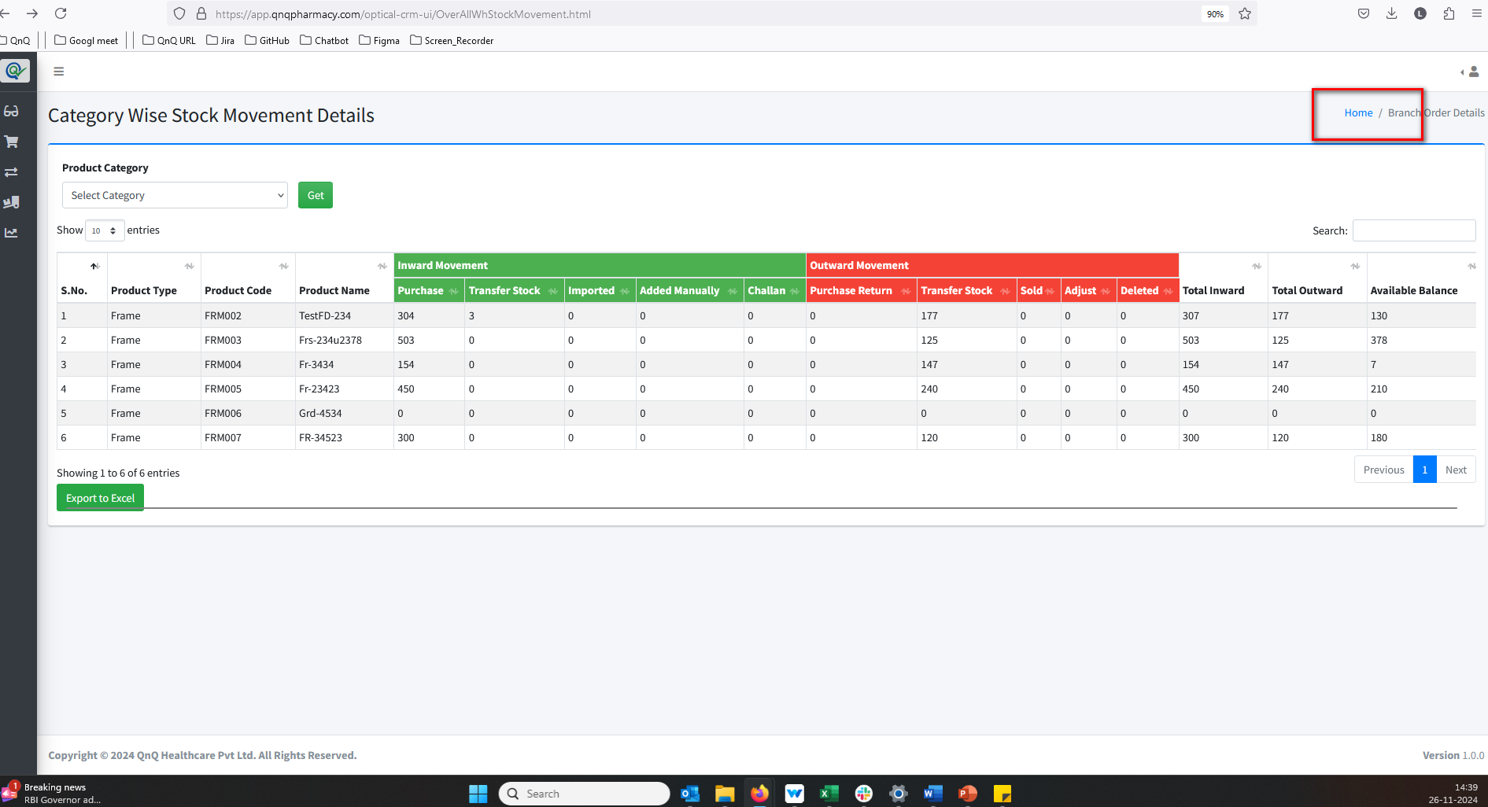 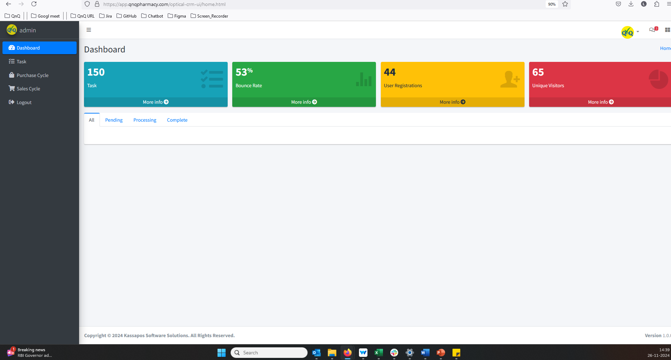 //
10. The button name is not displayed as "Get Details" or "Generate Report 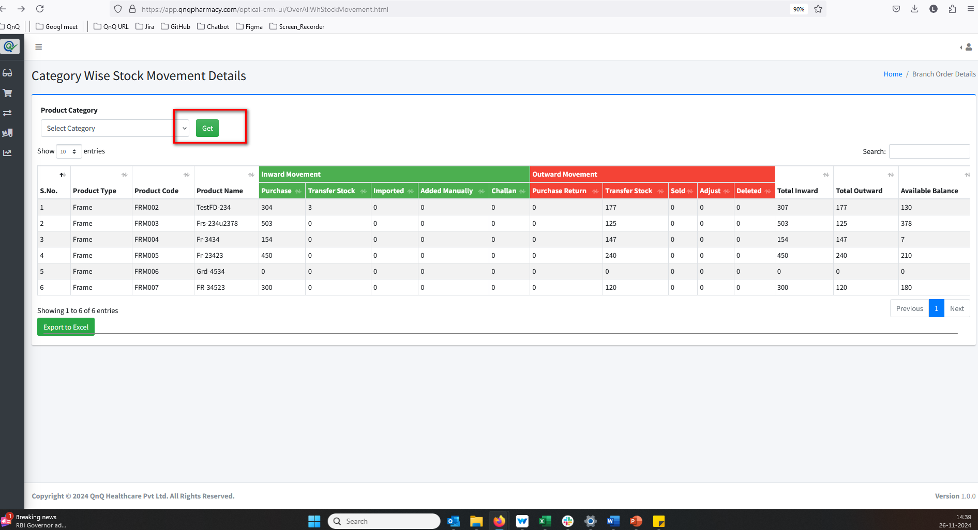 //
11. Challan and Imported value display as empty in History list grid 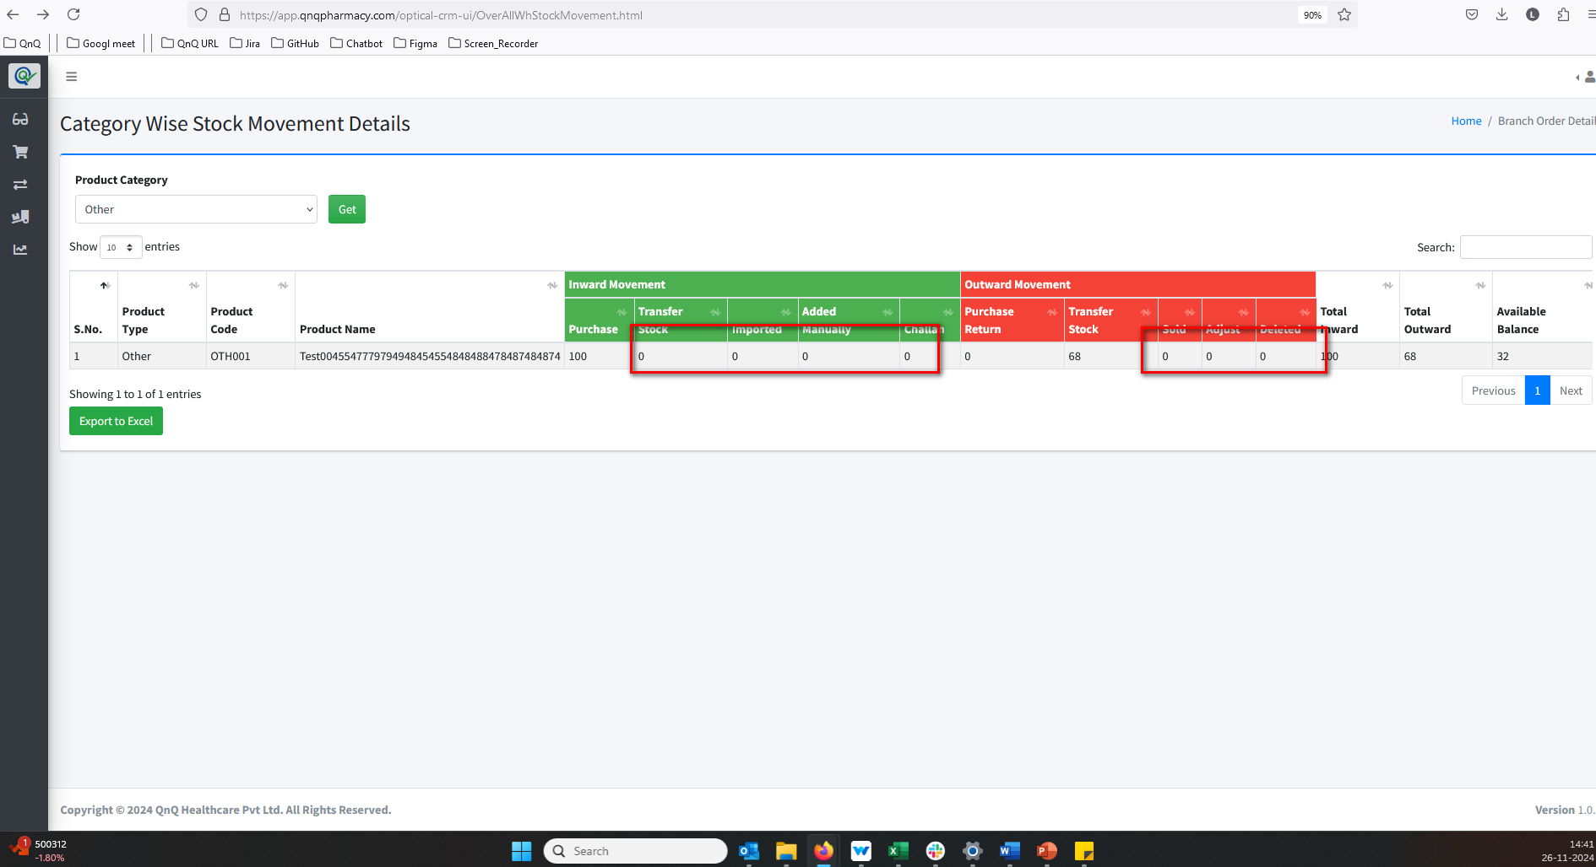 //
12. Placeholder/Inner Text not display in search field 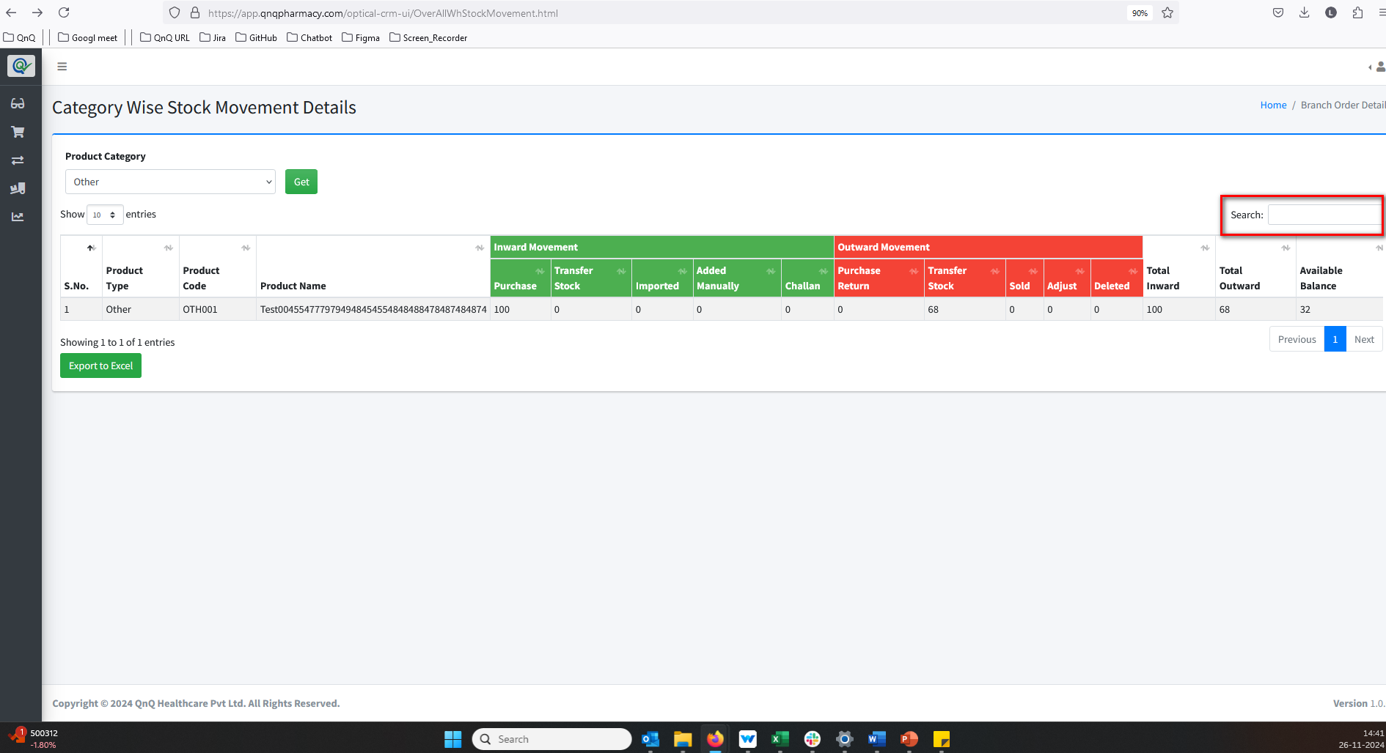 //
13. Mismatch values display in Category Wise list grid while update the records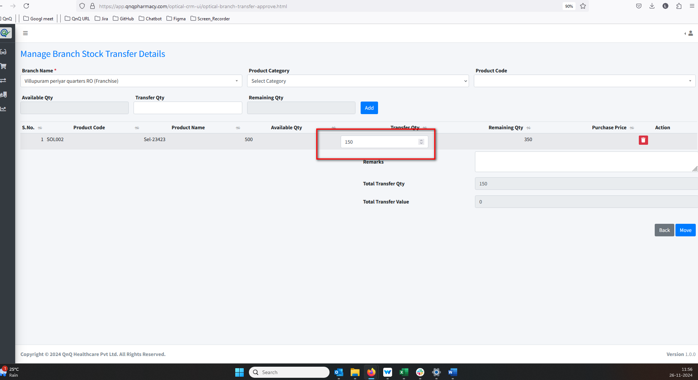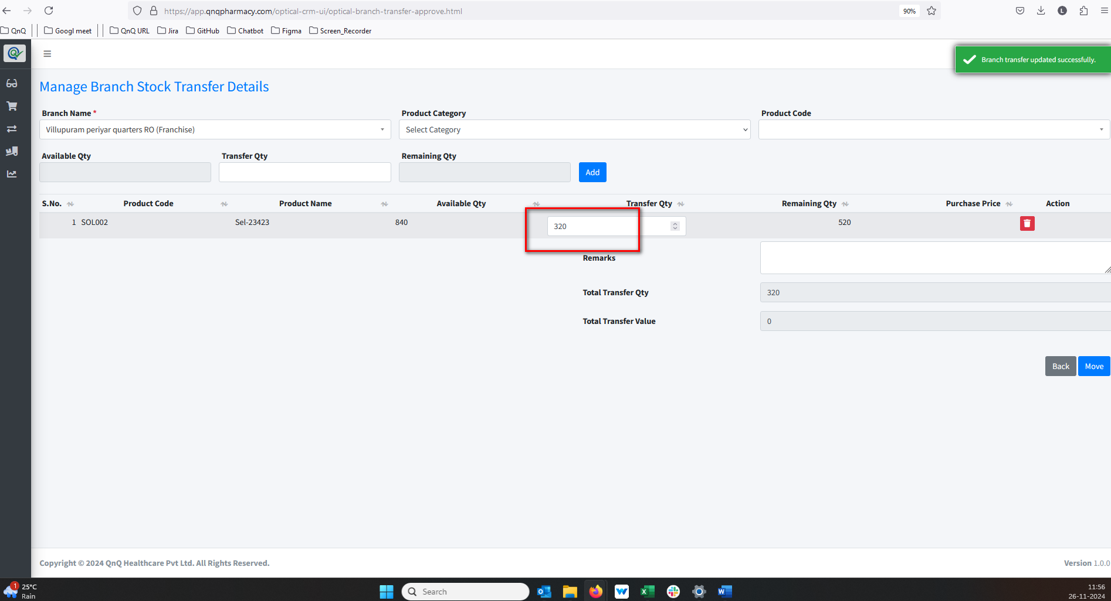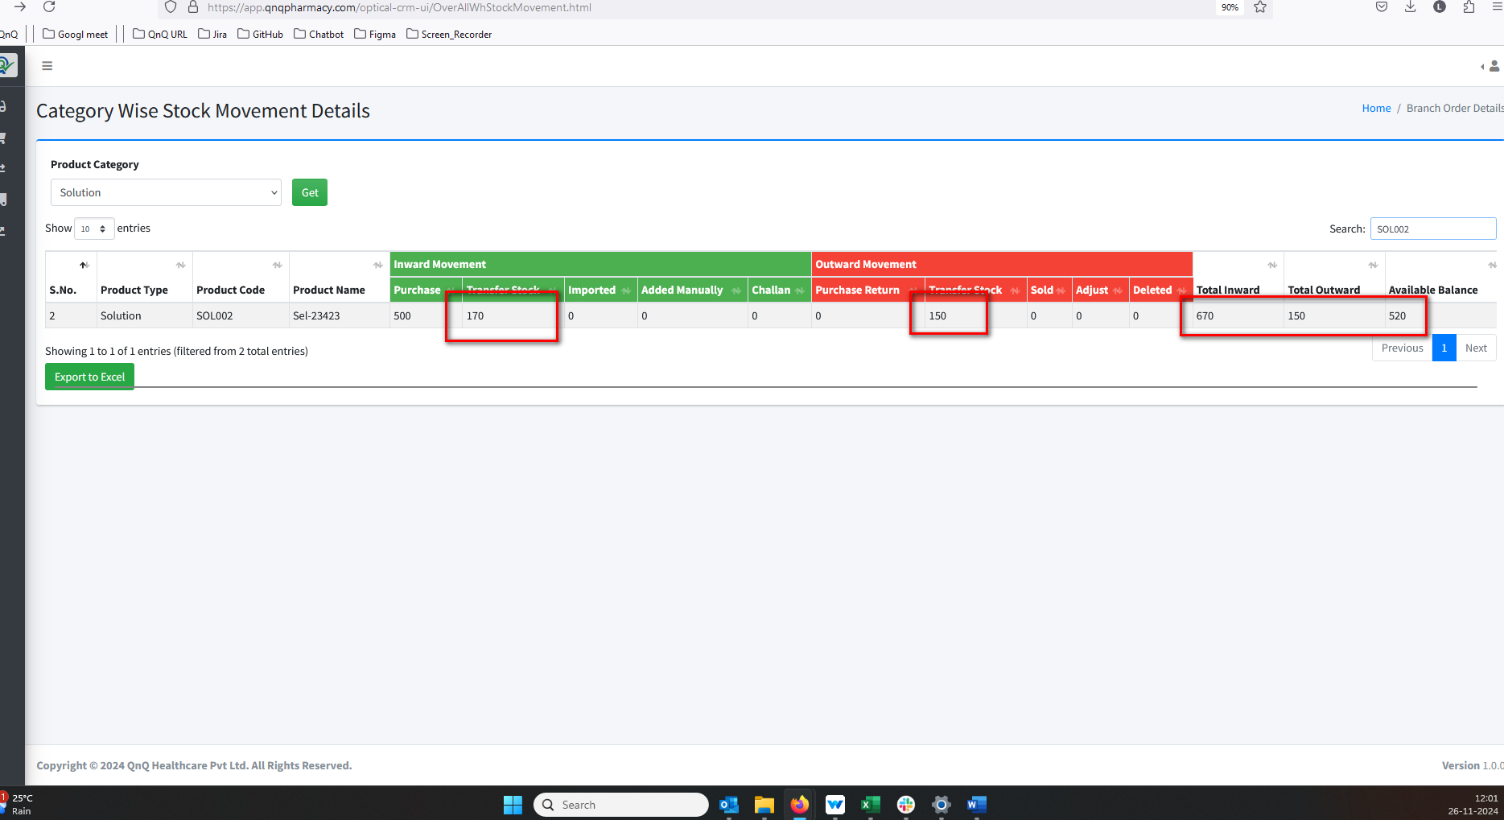//
14. The export button and scrollbar are misaligned 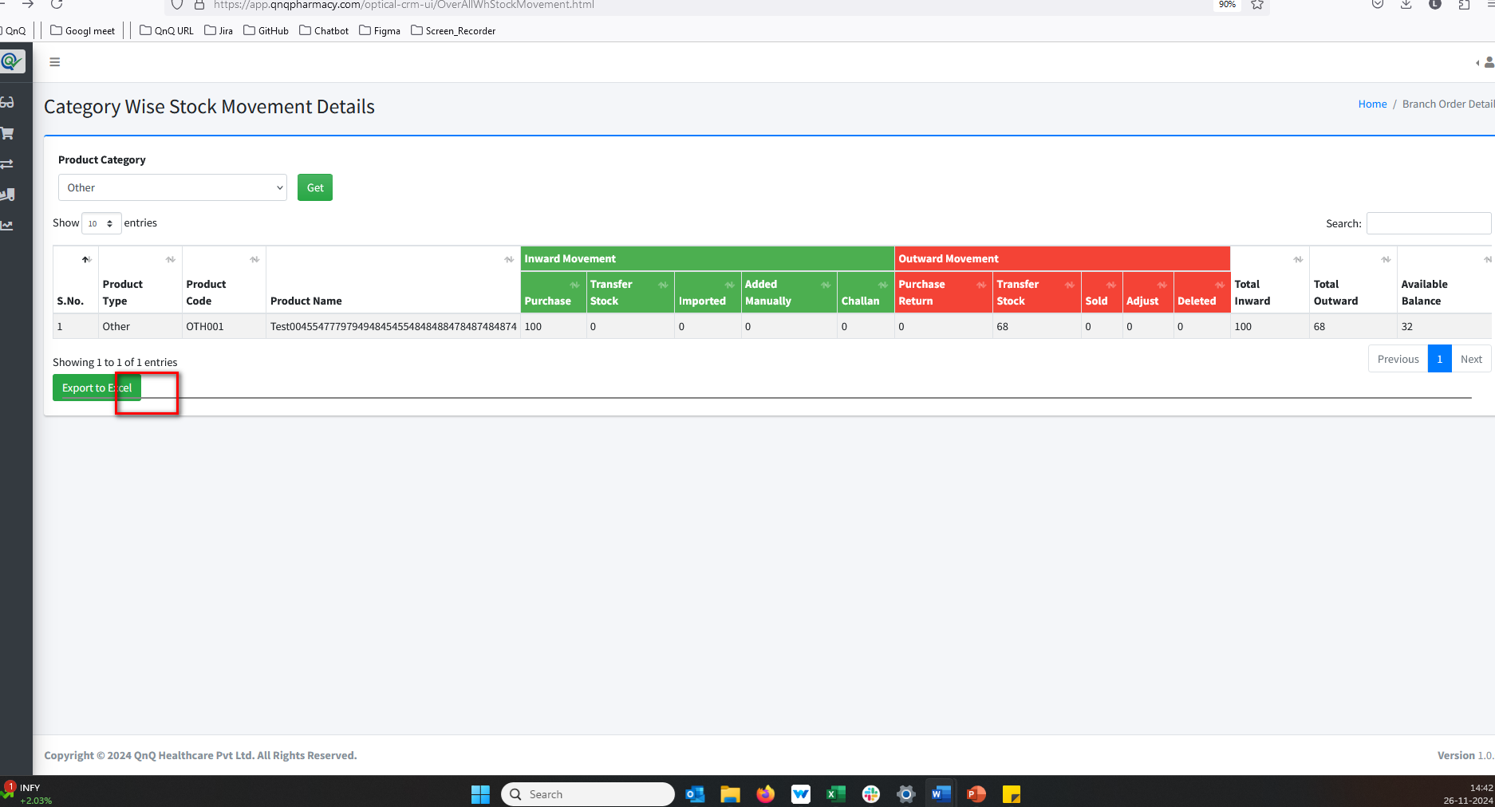 //
15. Improper alignment display in list grid 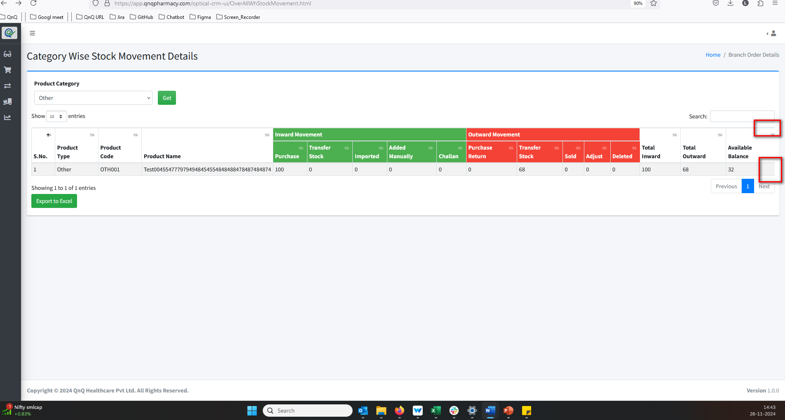 //
16. Group by column header not display middle of the column 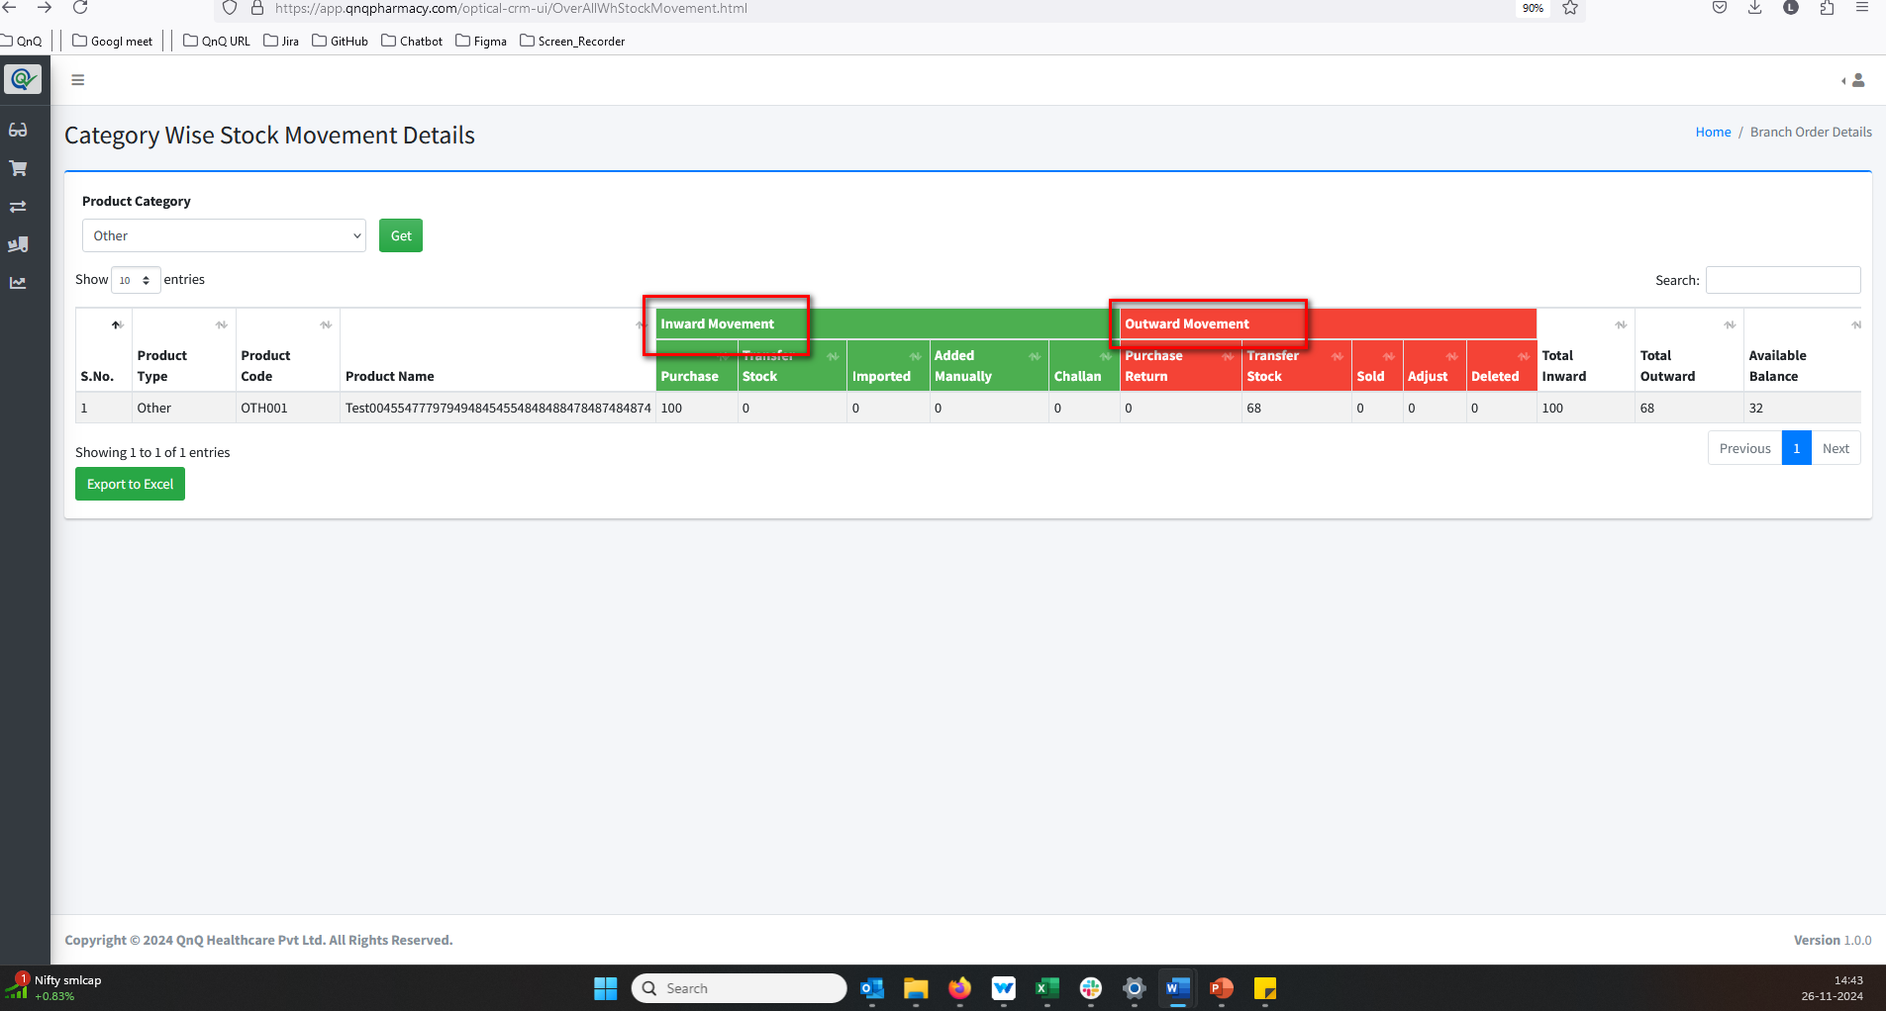 //
17. Menu name not display properly 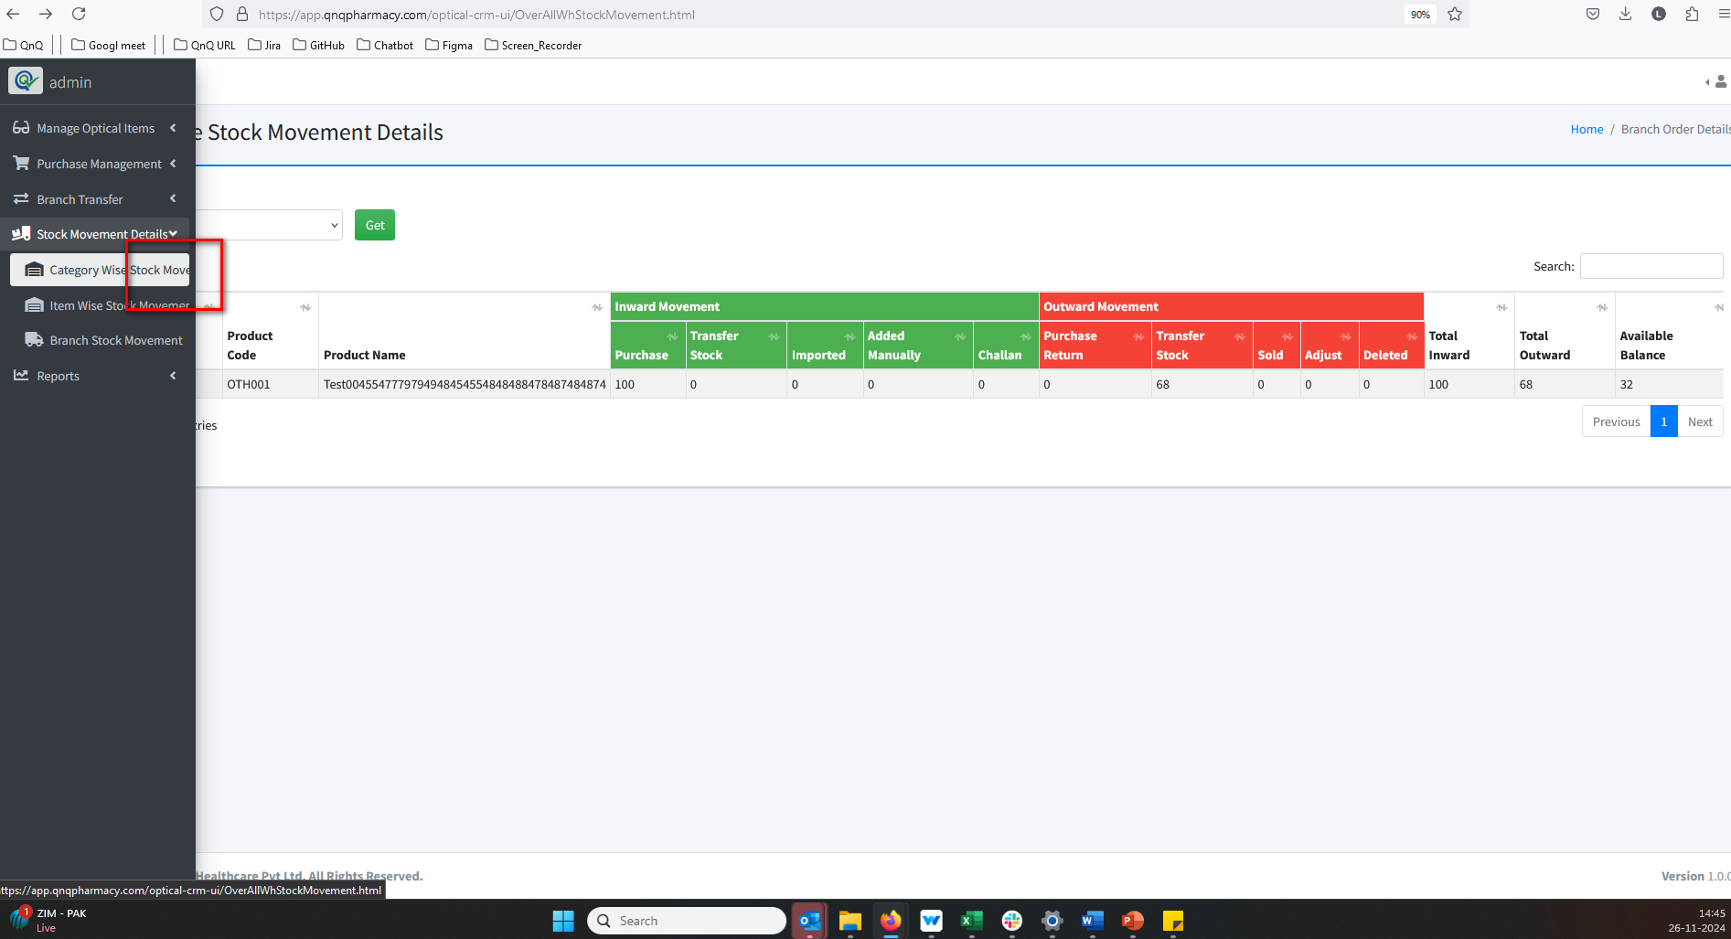 //
18. "Not Transfer Approved" appears in the Category Wise Stock Movement Details list grid 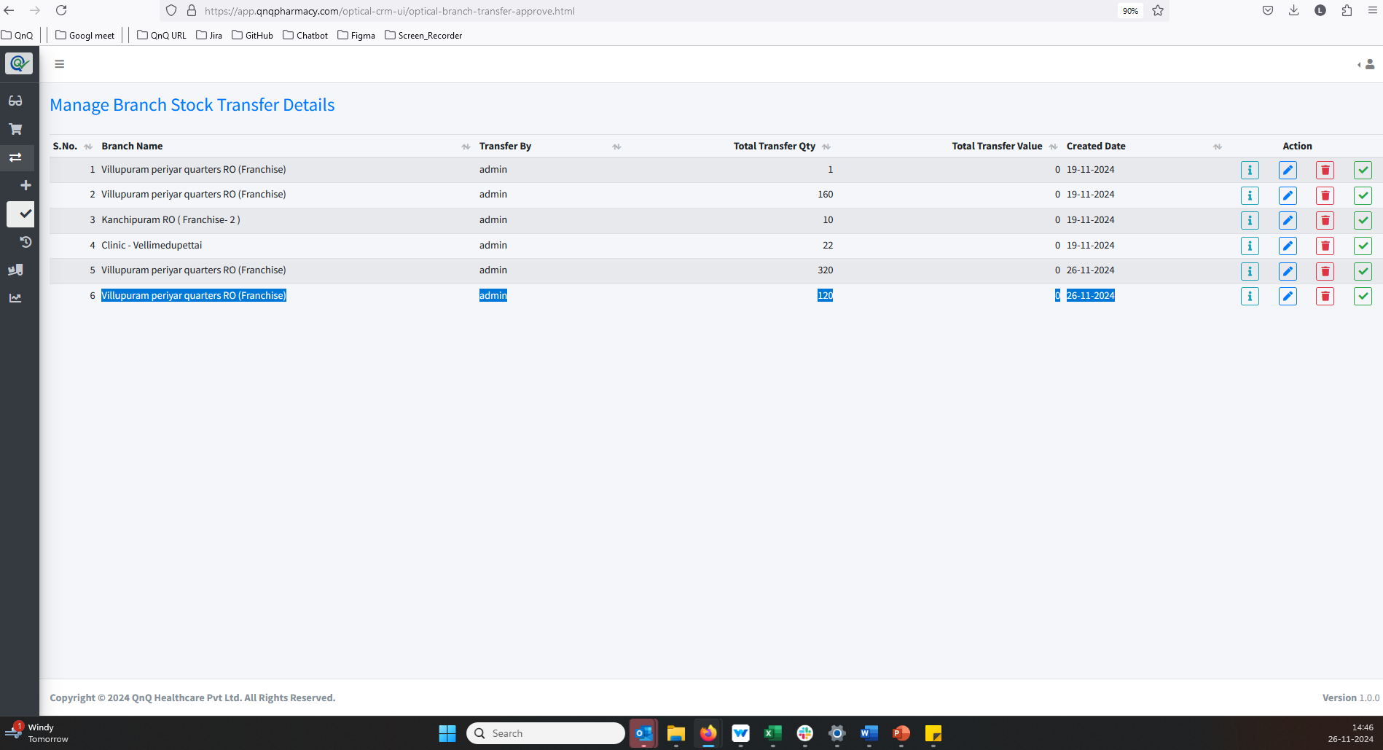 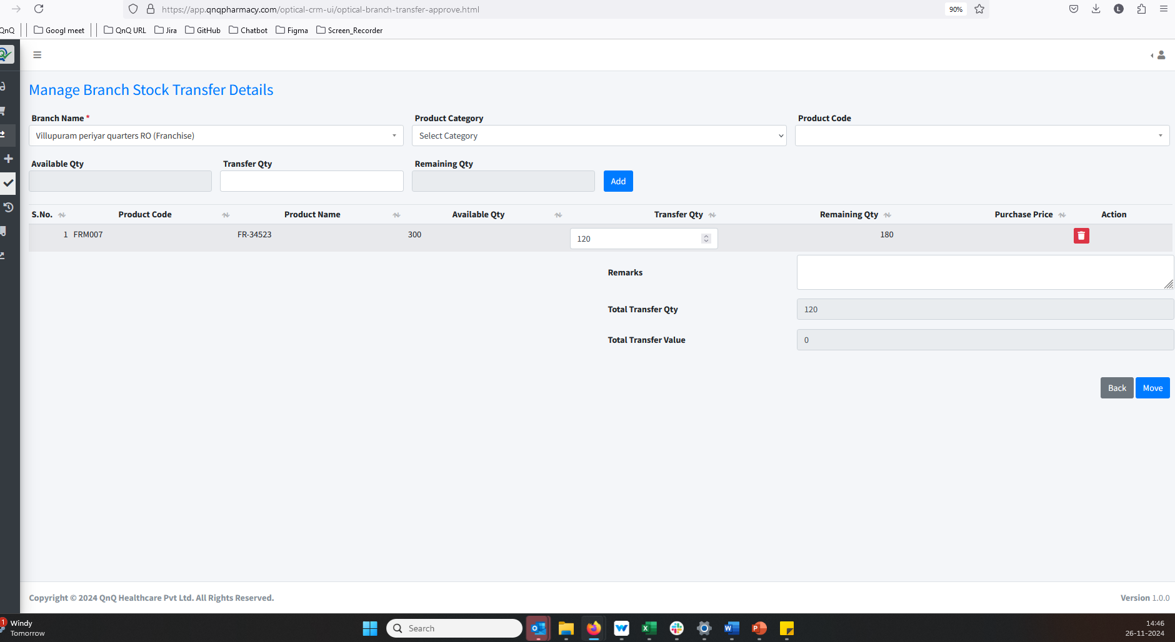 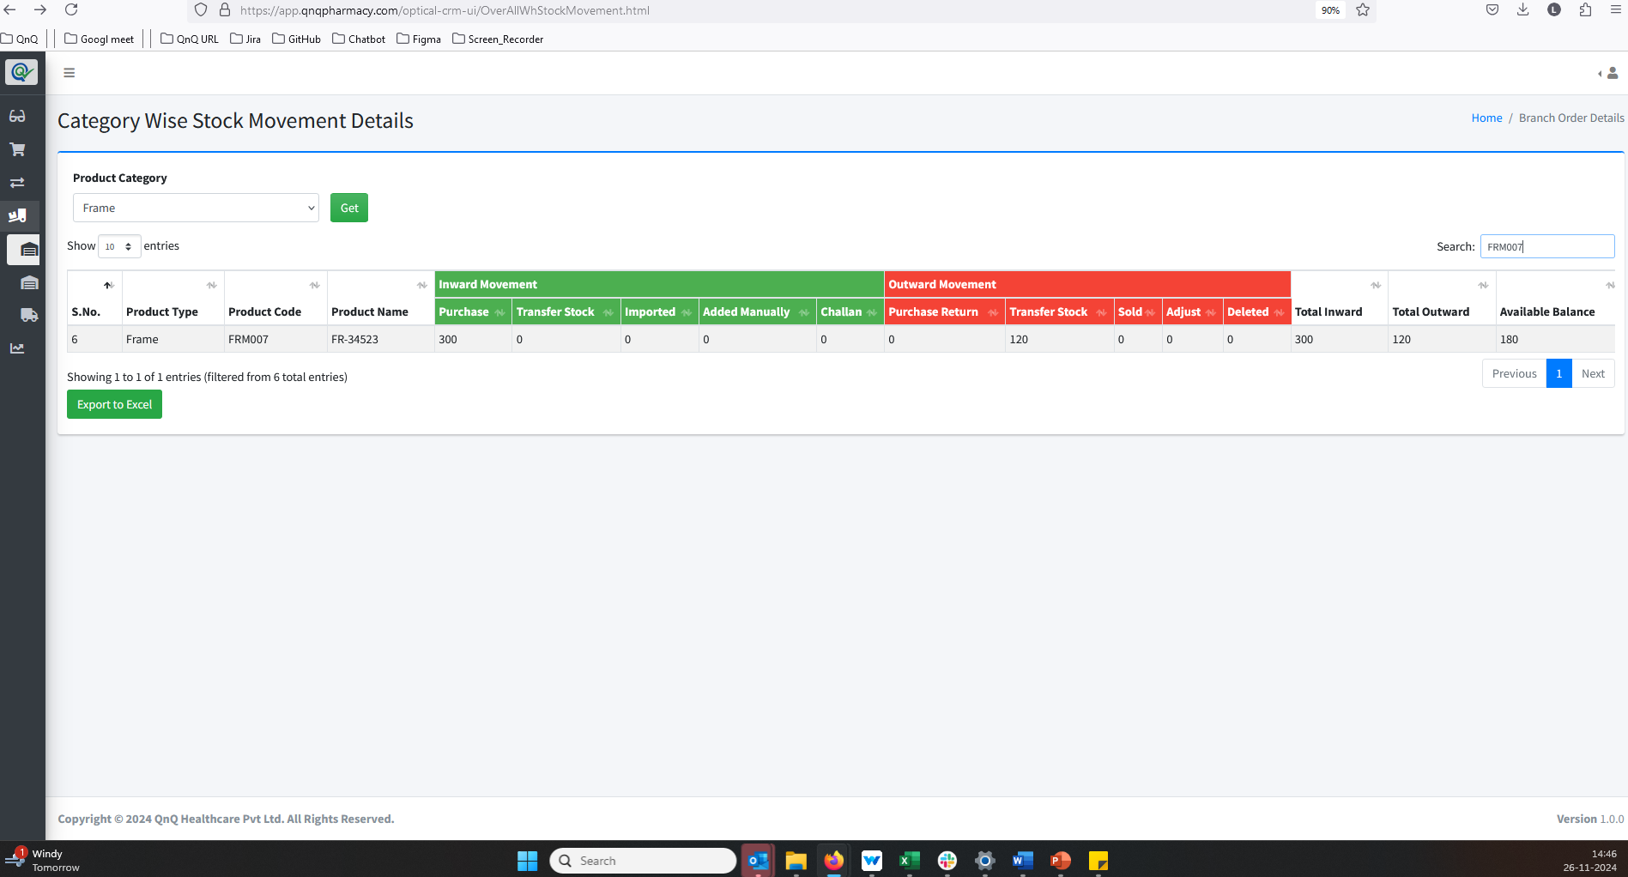 //
19. Mismatch column order alignment display in export excel  